**Step 1: Create a sample recipe file of httpd cookbook**

# vim /home/ubuntu/chef-repo/cookbooks/httpd/recipes/default.rb

service 'httpd' do

action [ :enable, :restart ]

end

## **Step 2: Upload Cookbook to chef-server**

# knife cookbook upload httpd

**Step 7 :** Apply the run list from UI and run chef-client on Ubuntu server

knife ssh "*:*" -x ec2-user --identity-file chef.pem "sudo chef-client"

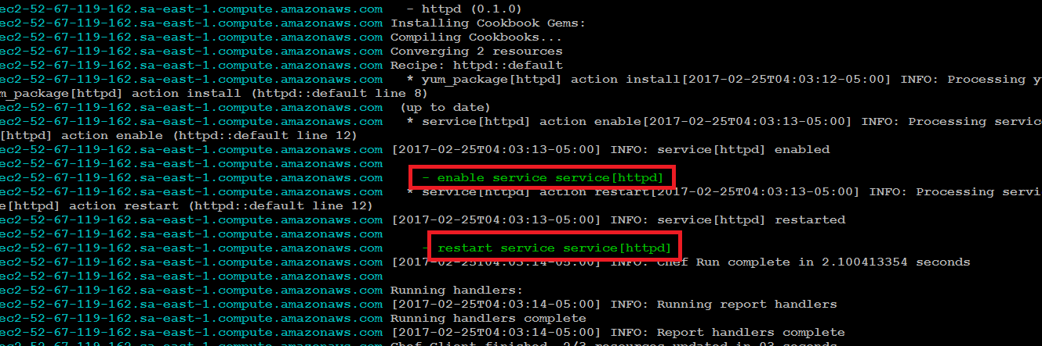

Validate on web browser if your web server is is up and index.html is available

